**MUSTANG GARAGE**

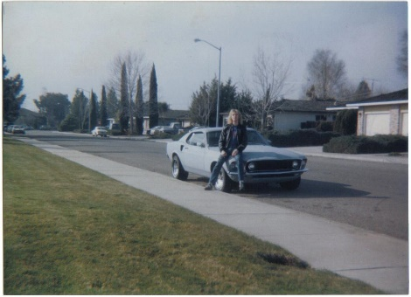**Back in the Day 1985**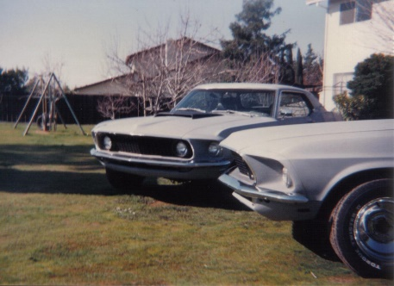

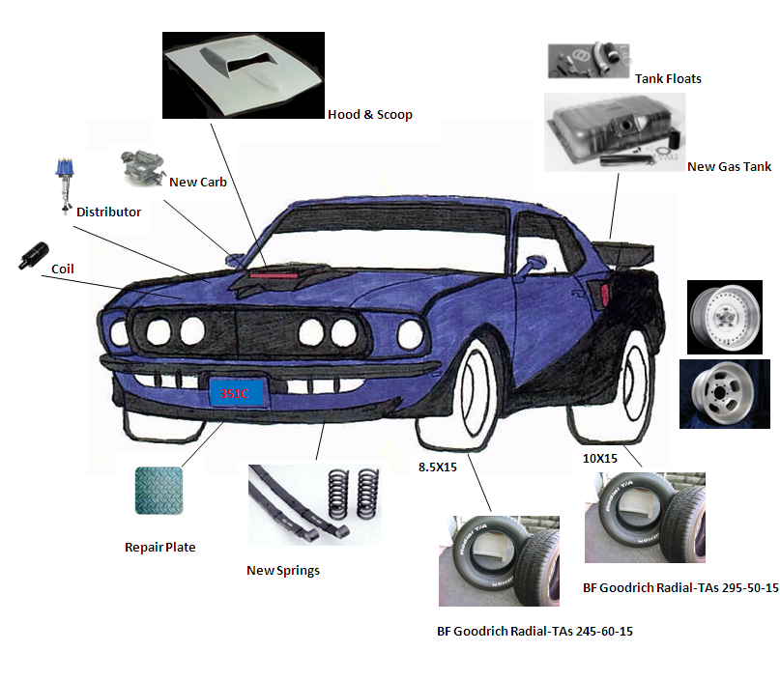

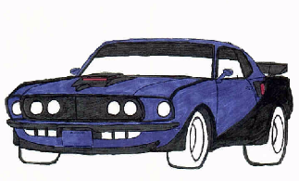

**PICTURES AT DAD’s BACK YARD 2021**

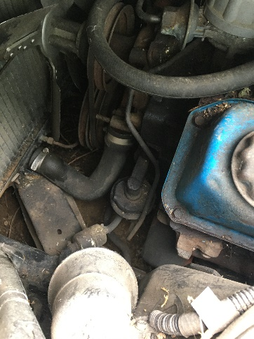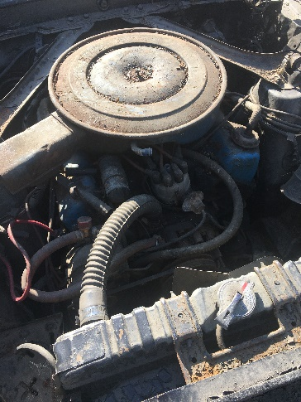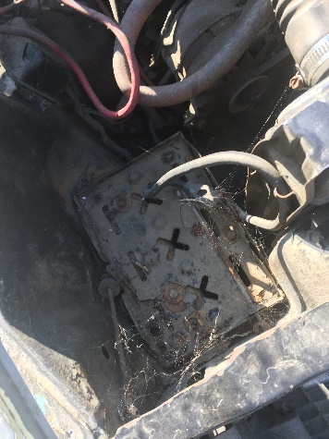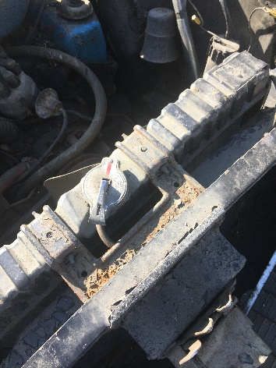

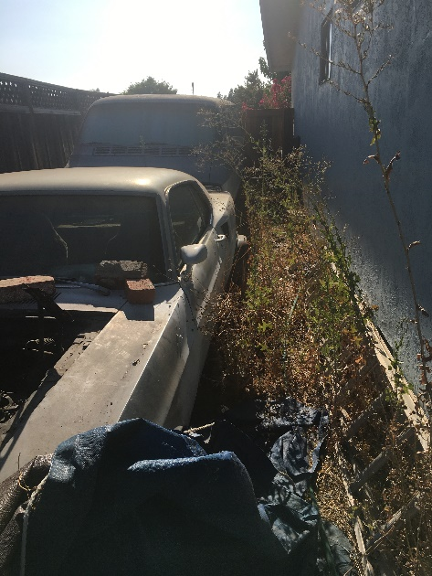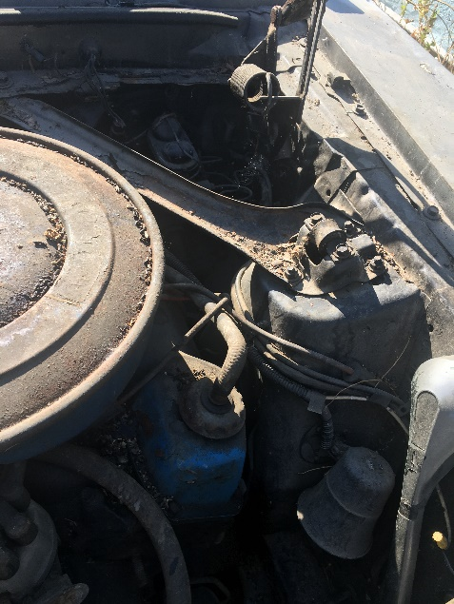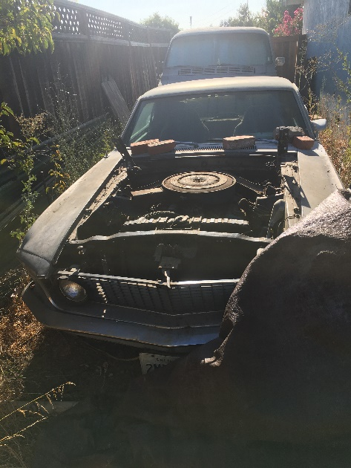

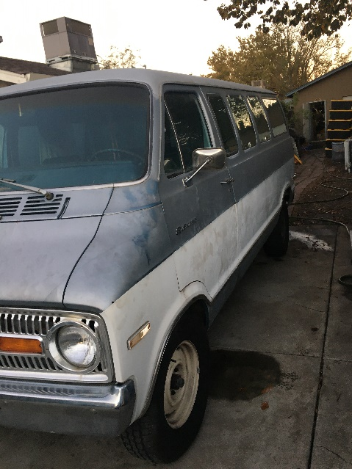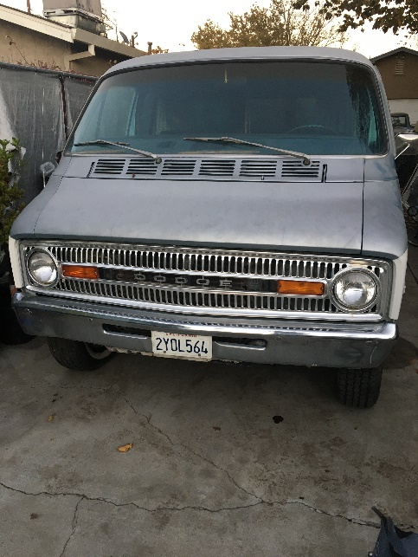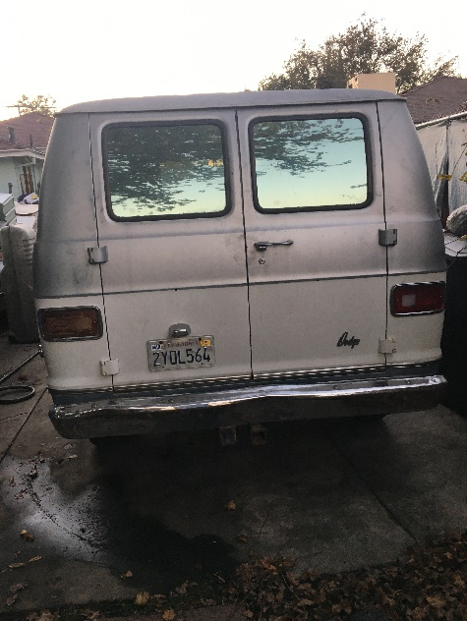

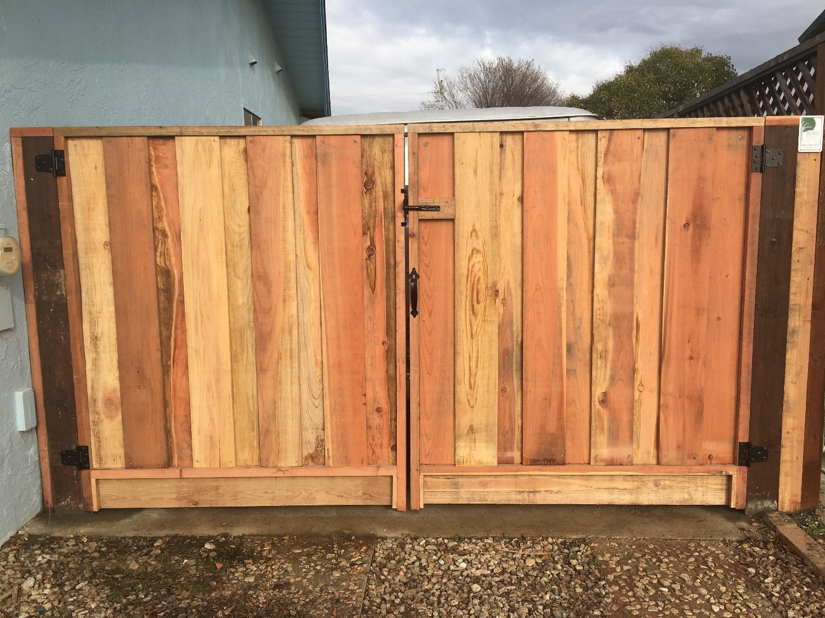

**Goodbye my home I grew up in. I will remember…**

**<<<Finally Home!**

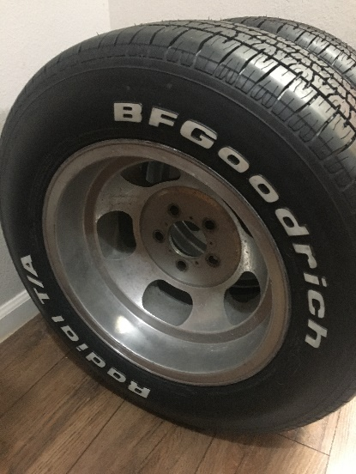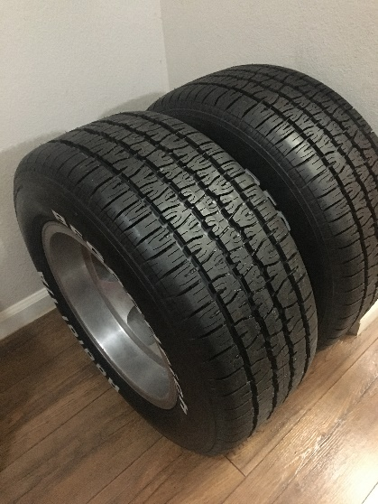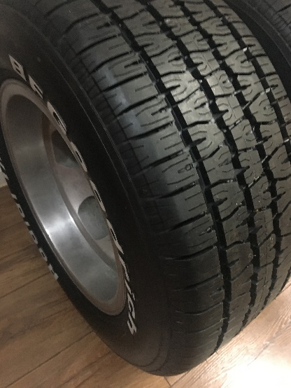

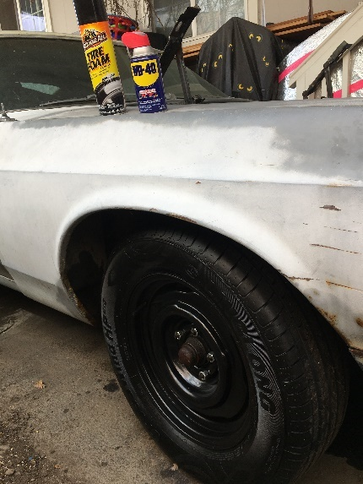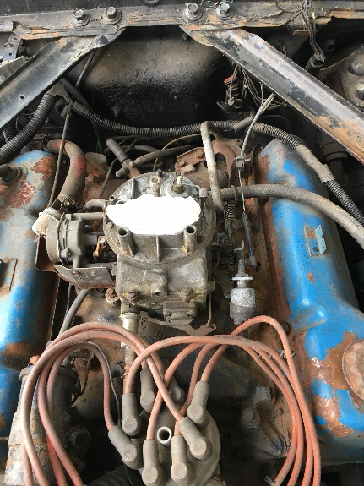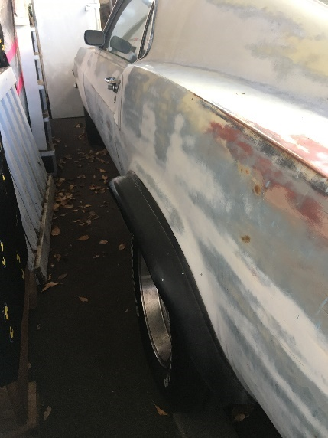

**Things bought to move Mustang to my Home:**

* **2 New MAX Batteries for Van & Mustang**
* **2 Front Wheels spares**
* **2 BFGoodrich 245/60 R15 Radial TAs on 8.5X15 Slot Mags!**

**Cleaning up the Engine Block:**

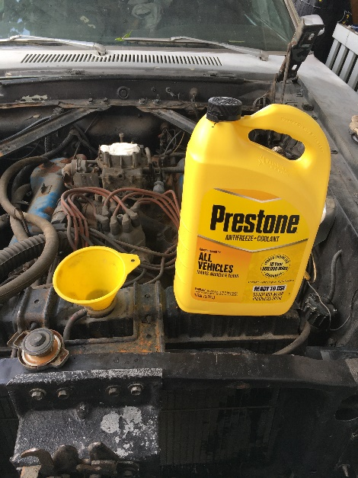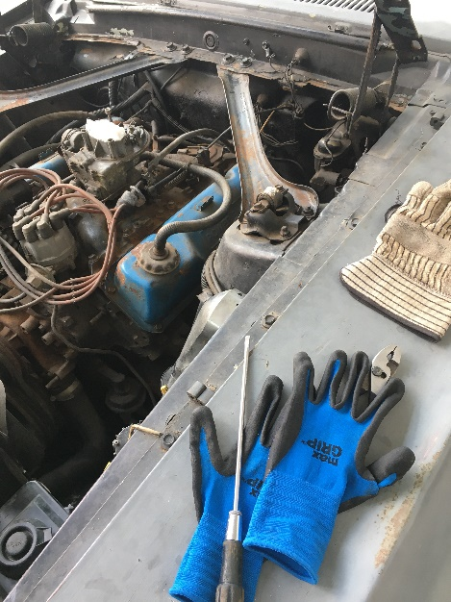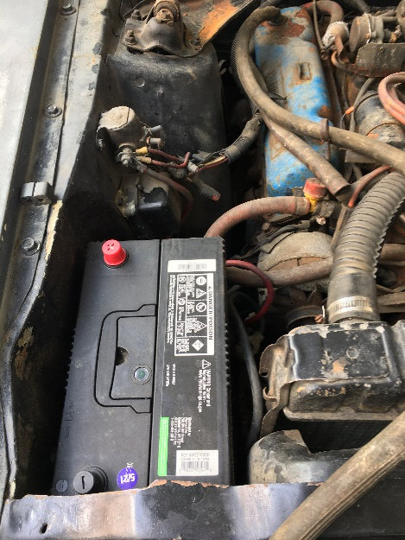

* **Electrical test for shorts/breaks**
* **New air filter**

**Oil Change & Mystery Lube: Drain oil, remove oil filter, replace oil filter & plug. Mix motor oil & Mystery Lube. Add oil/Lube… (1-29-23). Remove spark plugs & add oil/lube to cylinders + fogger. Replace & lube old sparks. Remove valve covers. Treat valves with oil/lube. Clean & paint valve covers. Add 351C decal. Clear coat valve covers. Replace valve covers, gaskets.**

**Turn Motor! (often)… Drain & replace radiator fluid.**



**• 2 BFGoodrich 295/50 R15 Radial TAs on 10X15 Slot Mags!**

**Oil Pressure Gauge Re-Install**

# **Blow out fuel lines (Videos) How to Clean Old Brake & Fuel Lines with Aerosol Injected Cleaner – Eastwood** [How to Clean Old Brake & Fuel Lines with Aerosol Injected Cleaner - Eastwood - YouTube](https://www.youtube.com/watch?v=3swnBRpneUQ)or **Seafoam**

* **Disconnect fuel line at both ends & purge line with Eastwood Injected Cleaner**

**Fuel tank/floats Install: (Videos) 1965-1970 MUSTANG | Fuel Tank Install | Fuel Sending Unit Install** <https://m.youtube.com/watch?v=R4btSJAj6jQ>

**Mustang Fuel Tank Kit with Drain Plug 1969** <https://www.cjponyparts.com/fuel-tank-kit-with-drain-plug-mustang-1969/p/FTK2/>

* **Parts & material organization**
* **Test & install sending unit**
* **Old tank Removal**
* **Prep trunk & tank for new & install**

**Fuel Pump install**

**

**

* **Coil, Cap, Rotor, Condenser, Points**
* **Spark Plug wires, Spark plugs, Spark Plug Wire Spacers**
* **>>> Upgrade to Electronic Ignition <<<**

**Vacuum Hose Replacement**

**FIRE IT UP!!!**

**Radiator Shroud & New Hose Install**

**Air Cleaner Paint & Decal**

**1969 Glue-In Glass: The Comprehensive Repair Guide**

[1969 Glue-In Glass: The Comprehensive Repair Guide - YouTube](https://www.youtube.com/watch?app=desktop&v=xoTKxAwmnCc)

**CJ Classics Mustang Leaf Spring Kit 5-Leaf Heavy Duty 1969-****1973** <https://www.cjponyparts.com/leaf-spring-kit-5-leaf-heavy-duty-mustang/p/LSK23/> **$365.37**

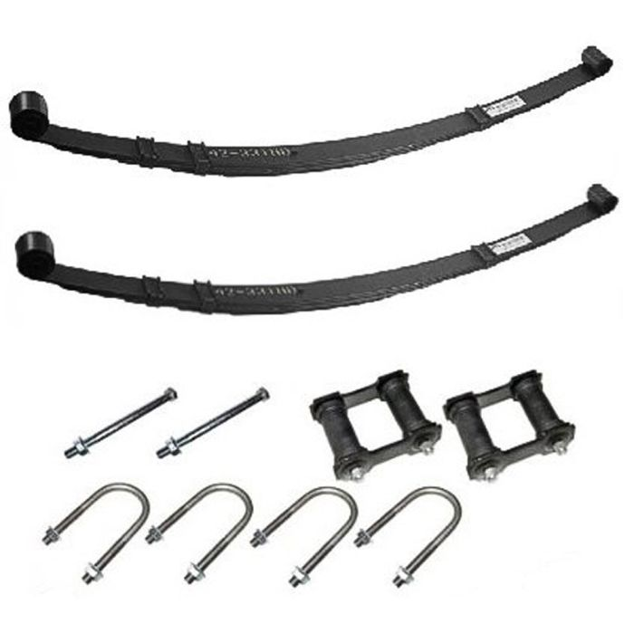

[Mustang Monroe Air Shock Kit (1965-1970) Installation Instructions (cjponyparts.com)](https://www.cjponyparts.com/mustang-monroe-air-shock-kit-1965-1970-installation-instructions/a/348/) **$99.99**

**Air Shock Kit Monroe 1965-1970**

**CJ's Part Number:**

AIRSHOCK

[1969 Ford Mustang Parts & Accessories | CJ Pony Parts](https://www.cjponyparts.com/1969-mustang-parts/c/60000000/)

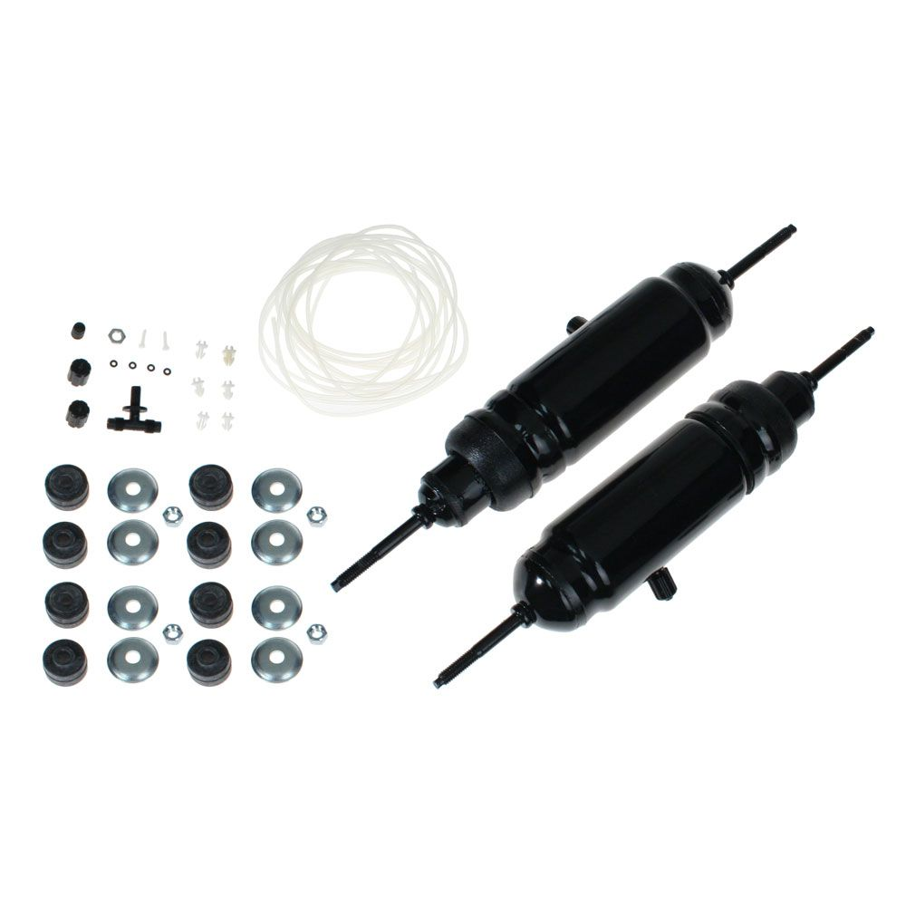

>PROCEDURE

-First

Wash Out

-Dump

**START HERE!**

**BOB’s Computer - XYZ MUSIC DRIVEs Passcode: amberlynn**

DEMON ROCK DRIVE + Band Audio Drives



[Greg Gibson , BOB Frost and Claude VanSant Wagon Wheel - YouTube](https://www.youtube.com/watch?v=Cnv2PKpyprA)

**BACKUP DRIVED:**

**XYZ MASTER BACKUPS**

**SEQ MASTER Drive**

**MASTER CDs**

**-MASTER CDs 100% Volume**

**Space Scenes**

**Niecee’s Stuff**

**HOT SPOT!!!**

**Guitar & Band Practice!**

MUSTANG Work & Garage!

ATARI! 800XL & floppy

TurboGrafx 16 CD TurboDuo! VHS to DVD Recordings!

GreenHouse! Mining!

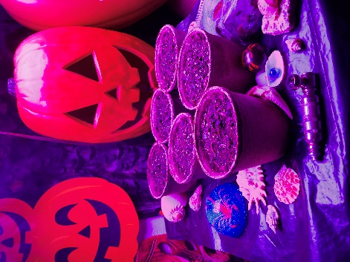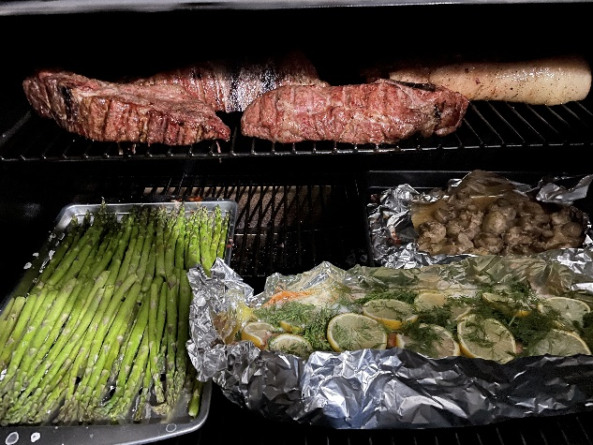[](KIA.docx)

VUE Smogged 2024! MUSTANG DEMON Work!!! AUDIO Recordings DataBase CDs

<http://metallhead.com/Music%20Files%202024/Band%20Recording%20Session.MOV>

[metallhead.com/Music Files 2024/Practice 10-14 2017 01.WAV](http://metallhead.com/Music%20Files%202024/Practice%2010-14%202017%2001.WAV)

New 16" x 6.5" Replacement Wheel for Kia Forte LXS 2022 Rim Wheel does not come with a center cap, lugs, or TPMS sensor. Original center cap, lugs, and TPMS sensors made for this specific wheel design will fit this wheel. **OE PART# 52910M7700 Aluminum**

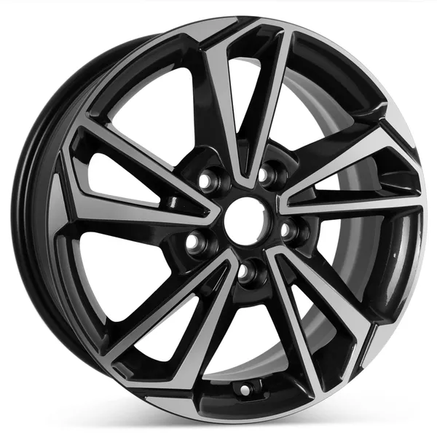

[Alpenzusjes - Wienie Wienie ( carnaval ) - YouTube](https://www.youtube.com/watch?v=Y_1PeG9hOJQ)

[Atomik Harmonik - Zavriskaj na ves glas (youtube.com)](https://www.youtube.com/watch?v=3N7kMvh7g_s)

[Atomik Harmonik - Kdo trka (youtube.com)](https://www.youtube.com/watch?v=T6JW3Q4rq7k)

[Alpenzusjes - Hitmix ( Mixed By Party DJ Rudie Jansen) (youtube.com)](https://www.youtube.com/watch?v=DI1x7yVSv0c)

[atomik harmonik concert! (youtube.com)](https://www.youtube.com/watch?v=9f1FszZrghY)